Music Library management system

Introduction to database project



**AMERICAN INTERNATIONAL UNIVERSITY BANGLADESH**

**(AIUB)**

**FACULTY OF SCIENCE & TECHNOLOGY**

**DEPARTMENT OF CSE**

**Project report on**

**Music Library management system**

**Supervised By**

**Supta Richard Philip**

**Submitted By**

|  |  |  |
| --- | --- | --- |
| NAME | ID | CONTRIBUTION |
| Saif Ahmed Ayon | 22-47572-2 | Intro+Case study |
| Sourav Saha | 22-47911-2 | ER diagram+Normalization |
| Md.Abdullah Al Noman | 22-47844-2 | Finalization+Table description |
| Ujjoyeni Dey | 22-49001-3 | Table data insertion+Query+conclusion |

Contents

1. Introduction 2

2. Case Study 3

3. ER Diagram 4

4. Normalization .5-7

5. Finalization…………………………………………………………………………………8-9

6. Table Description……………………………………………………………………..….10-16

7. Table Data Insertion 17-23

8. Query 24-31

9. Conclusion 32

# Introduction

A music library management system in a database is a software application that helps music library management and organize various aspects of their operations. The music database management project is to categorize and catalog every single piece of music for music info and reviews, review albums, listing record collections. The idea of music database arose out of common interest of project member in music. The concept seemed different and very interesting right in the first go.

# Case Study

# MUSIC LIBRARY MANAGEMENT SYSTEM CASE STUDY

In a music library management system, a user can listen to tracks/songs. A user can listen to many tracks and one track can also be listened to by many users. The system stores the  
user id (primary key), username and user email. A track is identified by the track id, track name, track creation date, and duration. Users can make playlists. One user can make many playlists, but one playlist can only be made by exactly one user. The playlist contains tracks. One playlist can contain many tracks and one track can be in many playlists. The system stores the playlist id, playlist name, and playlist created date. Artist  
composes track. A track may be composed by many artists and one artist can compose many tracks. The system stores the artist id, artist name, performer and nationality, of the artists who  
created at least one track. An artist creates an Album. An album may be created by many artists and one artist can create many albums. Albums are identified by album id, album name, and album date created. One artist has to create at least one track or an album. Album has tracks. One album may contain many tracks and one track can only belong to one album. Tracks belong to genres. One track can belong to multiple genres and for one genre  
there can be multiple tracks. Genre is specified by genre id, and genre name

# ER Diagram

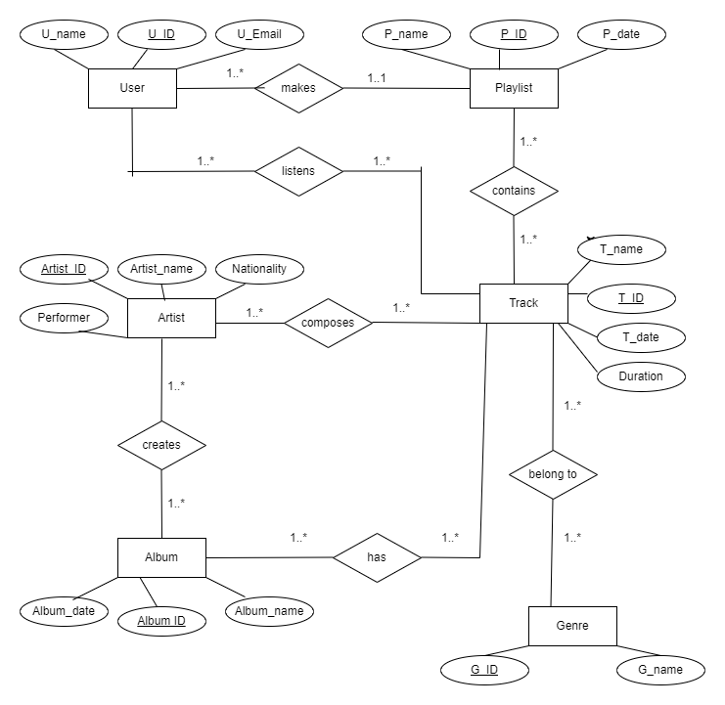

# Normalization

UNF (makes): U_ID, U_Name, U_Email, P_ID, P_Name, P_Date

1NF: **U-ID**, U_Name, U_Email,

**P-ID**, P_Name, P_Date

2NF: 1) **U-ID**, U_Name, U_Email, P_ID (FK)

2) **P-ID**, P_Name, P_Date

3NF: Same as 2NF

UNF (contains): P_ID, P_Name, P_Date, T_Date, T_Name, T_ID, Duration

1NF: **P-ID**, P_Name, P_Date

**T-ID**, T_Name, T_Date, Duration

2NF: 1) **P-ID**, P_Name, P_Date

2) **T-ID**, T_Name, T_Date, Duration

3) P_ID (PK), T_ID (FK) / P_ID (FK), T_ID (PK)

3NF: Same as 2NF

UNF (listens): U_ID, U_Name, U_Email, T_Date, T_Name, T_ID, Duration

1NF: **U-ID**, U_Name, U_Email

**T-ID**, T_Date, T_Name, Duration

2NF: 1) **U-ID**, U_Name, U_Email

2) **T-ID**, T_Date, T_Name, Duration

3) U_ID (PK), T_ID (FK) / U_ID (FK), T_ID (PK)

3NF: Same as 2NF

UNF (belongs): T_Date, T_Name, T_ID, Duration, G_ID, G_Name

1NF: **T-ID**, T_Date, T_Name, Duration, **G-ID**, G_Name

2NF: 1) **T-ID**, T_Date, T_Name, Duration

2) **G-ID**, G_Name

3) T_ID (PK), G_ID (FK) / T_ID (FK), G_ID (PK)

3NF: Same as 2NF

UNF (composes): Artist_ID, Artist_Name, Nationality, PerformerNo, T_Date, T_ID, T_Name, Duration

1NF: **Artist-ID**, Artist_Name, Nationality , PerformerNo

**T-ID**, T_Date, T_Name, Duration

2NF: 1) **Artist-ID**, Artist_Name, Nationality, PerformerNo

2) **T-ID** ,T_Date, T_Name, Duration

3) Artist_ID (PK), T_ID (FK) / Artist_ID (FK), T_ID (PK)

3NF: Same as 2NF

UNF (creates): Artist_ID, Artist_Name, Nationality, PerformerNo, Album_ID, Album_Name, Album_date

1NF: **Artist-ID**, Artist_Name, Nationality, PerformerNo

**Album-ID**, Album_Name, Album_date

2NF: 1) **Artist-ID**, Artist_Name, Nationality, PerformerNo

2) **Album-ID**, Album_Name, Album_date

3) Artist_ID (PK), Album_ID (FK) / Artist_ID(FK), Album_ID (PK)

3NF: Same as 2NF

UNF (has): Album_ID, Album_Name, Album_Date, T_Date, T_Name, T_ID, Duration

1NF: **Album-ID**, Album_Name, Album_Date

**T-ID**, T_Name, T_Date, Duration

2NF: 1) **Album-ID**, Album_Name, Album_Date, T_ID (FK)

2) **T-ID**, T_Name, T_Date, Duration

3NF: Same as 2NF

# Finalization

1) U-ID, U_Name, U_Email, P_ID (FK)

2) P-ID, P_Name, P_Date

~~3) P-ID, P_Name, P_Date~~

4) T-ID, T_Name, T_Date, Duration

5) P_ID (PK), T_ID (FK)

6) U-ID, U_Name, U_Email

~~7) T-ID, T_Date, T_Name, Duration~~

8) U_ID (PK), T_ID (FK)

~~9) T-ID, T_Date, T_Name, Duration~~

10) G-ID, G_Name

11) T_ID (PK), G_ID (FK)

12) Artist-ID, Artist_Name, Nationality, PerformerNo

~~13) T-ID ,T_Date, T_Name, Duration~~

14) Artist_ID (PK), T_ID (FK)

~~15) Artist-ID, Artist_Name, Nationality,~~ ~~PerformerNo~~

16) Album-ID, Album_Name, Album_date

17) Artist_ID (PK), Album_ID (FK)

18) Album-ID, Album_Name, Album_Date, T_ID (FK)

~~19) T-ID, T_Name, T_Date, Duration~~

## **Final Tables**

1)**U-ID**, U_Name, U_Email

2) **P-ID**, P_Name, P_Date

3) **U-ID**, U_Name, U_Email, P_ID (FK)

4) **T-ID**, T_Name, T_Date, Duration

5 **Artist-ID**, Artist_Name, Nationality

6)**Album-ID**, Album_Name, Album_Date

7) **Album-ID**, Album_Name, Album_Date, T_ID (FK)

8) **G-ID**, G_Name

9) P_ID (PK), T_ID (FK)

10) U_ID (PK), T_ID (FK)

11) T_ID (PK), G_ID (FK)

12) Artist_ID (PK), T_ID (FK)

13) Artist_ID (PK), Album_ID (FK)

**Total tables: 13**

# Table Description

1) CREATE TABLE m_user (

U_ID number(5) primary key NOT NULL,

U_Name varchar2(200) NOT NULL,

U_Email varchar2(200)

);

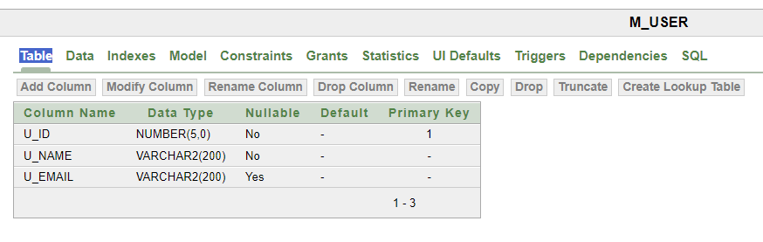

2) CREATE TABLE playlist (

P_ID number (5) PRIMARY KEY NOT NULL,

P_Name varchar2(200) NOT NULL,

P_Date date NOT NULL

);

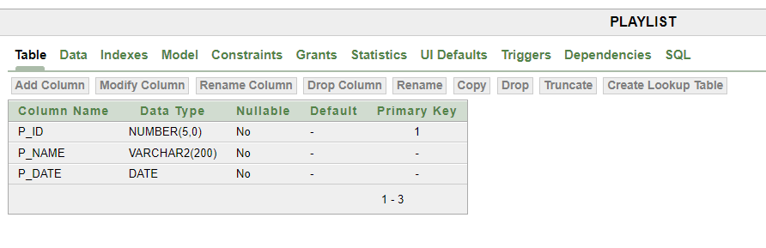

3) CREATE TABLE tracks (

T_ID number (5) PRIMARY KEY NOT NULL,

T_Name varchar2(200) NOT NULL,

T_Date date NOT NULL,

T_Duration number(4,2) NOT NULL

);

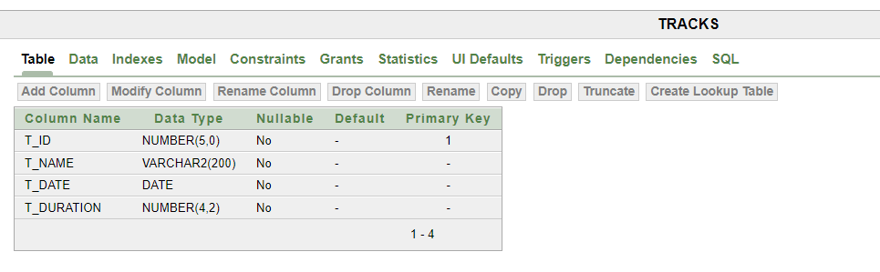

4) CREATE TABLE artist (

Artist_ID number (5) PRIMARY KEY NOT NULL,

Artist_Name varchar2(200) NOT NULL,

Artist_Nationality varchar2(200),

Artist_Performer varchar2(200),

);

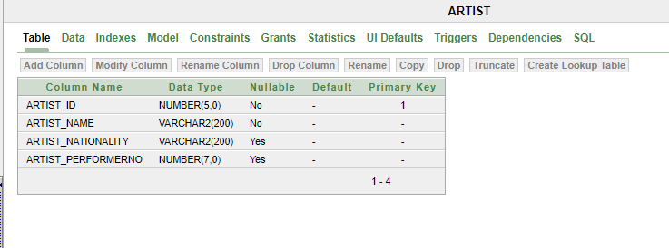

5) CREATE TABLE album (

Album_ID number (5) PRIMARY KEY NOT NULL,

Album_Name varchar2(200) NOT NULL,

Album_Date date NOT NULL

);

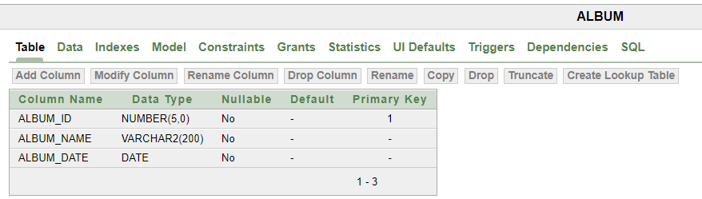

6) CREATE TABLE genre (

G_ID number (5) PRIMARY KEY NOT NULL,

G_Name varchar2(200) NOT NULL

);

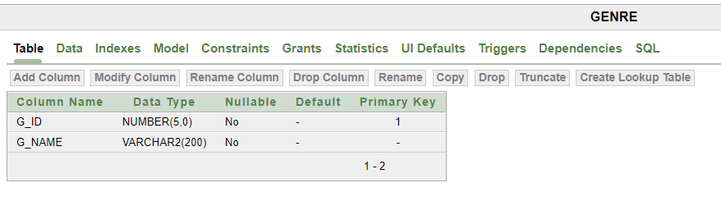

7) CREATE TABLE makes (

U_ID number(5) primary key NOT NULL,

U_Name varchar2(200) NOT NULL,

U_Email varchar2(200),

P_ID number(5) NOT NULL,

CONSTRAINT P_ID FOREIGN KEY (P_ID)

REFERENCES Playlist(P_ID)

);

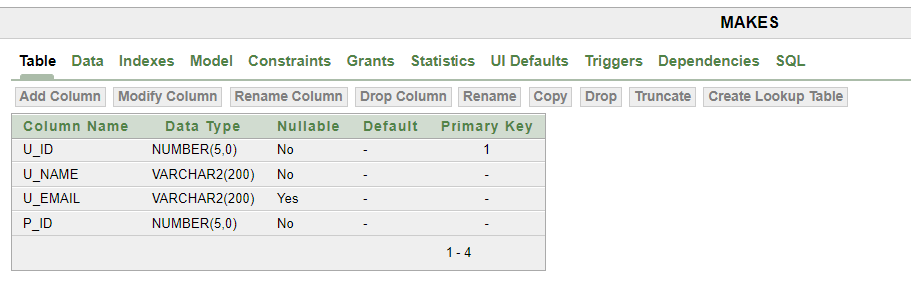

8) CREATE TABLE listens (

U_ID number(5) PRIMARY KEY NOT NULL,

T_ID number(5) NOT NULL,

CONSTRAINT tid4 FOREIGN KEY (T_ID)

REFERENCES tracks(T_ID)

);

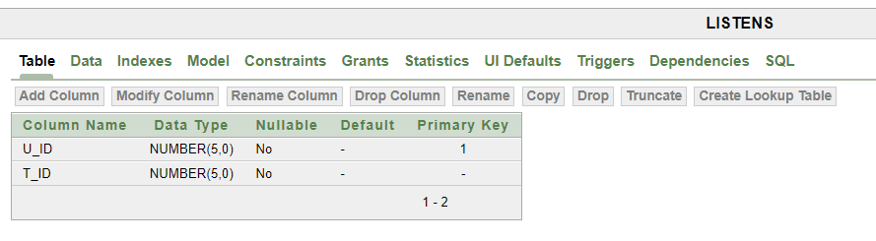

9) CREATE TABLE contains (

P_ID number(5) PRIMARY KEY NOT NULL,

T_ID number(5) NOT NULL,

CONSTRAINT tid FOREIGN KEY (T_ID)

REFERENCES tracks(T_ID)

);

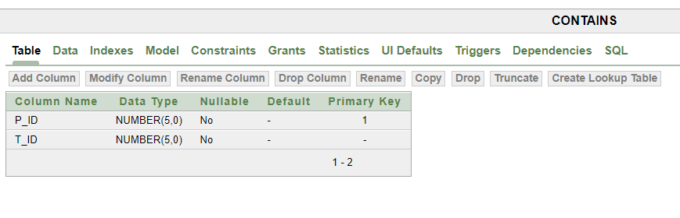

10) CREATE TABLE composes (

Artist_ID number(5) PRIMARY KEY NOT NULL,

T_ID number(5) NOT NULL,

CONSTRAINT tid3 FOREIGN KEY (T_ID)

REFERENCES tracks(T_ID)

); 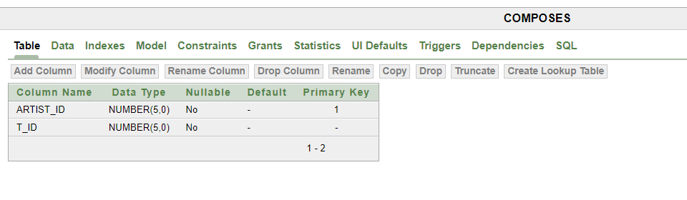

11) CREATE TABLE creates (

Artist_ID number(5) PRIMARY KEY NOT NULL,

Album_ID number(5) NOT NULL,

CONSTRAINT albumid FOREIGN KEY (Album_ID)

REFERENCES album(Album_ID)

);

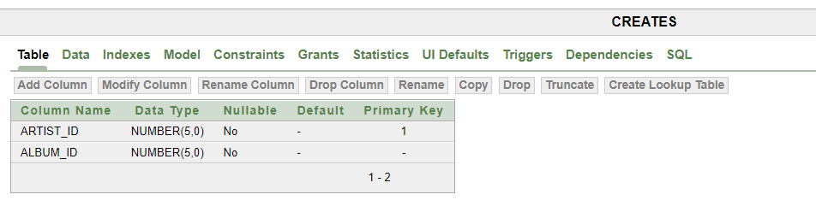

12) CREATE TABLE has (

Album_ID number (5) PRIMARY KEY NOT NULL,

Album_Name varchar2(200) NOT NULL,

Album_Date date NOT NULL,

T_ID number (5) NOT NULL,

CONSTRAINT tid2 FOREIGN KEY (T_ID)

REFERENCES tracks(T_ID)

);

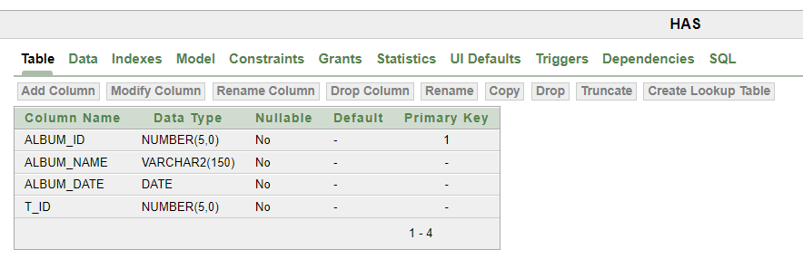

13) CREATE TABLE belongs (

T_ID number(5) PRIMARY KEY NOT NULL,

G_ID number(5) NOT NULL,

CONSTRAINT gid FOREIGN KEY (G_ID)

REFERENCES genre(G_ID)

);

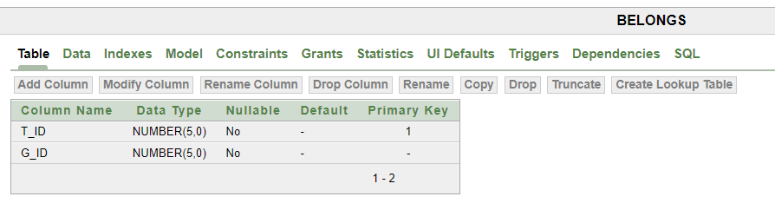

**7. Table Data Insertion**

1) For m_user table :

INSERT into m_user values(101, 'Ujjoyeni' , 'ujjoyeni@gmail.com');

INSERT into m_user values(102, 'Noman' , 'noman@gmail.com');

INSERT into m_user values(103, 'Saif' , 'saif@gmail.com');

INSERT into m_user values(104, 'Sourav' , 'sourav@gmail.com');

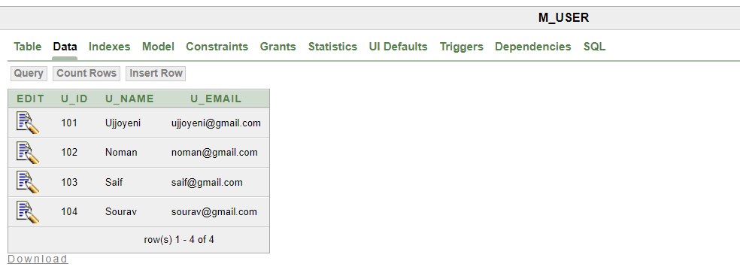

2) For playlist table :

INSERT into playlist values(28, 'Pop' , ‘18-Apr-23’);

INSERT into playlist values(48, 'Romantic' , ‘12-Sep-22’);

INSERT into playlist values(71, ' Hip hop' , ‘4-Dec-22’);

INSERT into playlist values(94, ' Rock' , ‘9-Mar-22’);

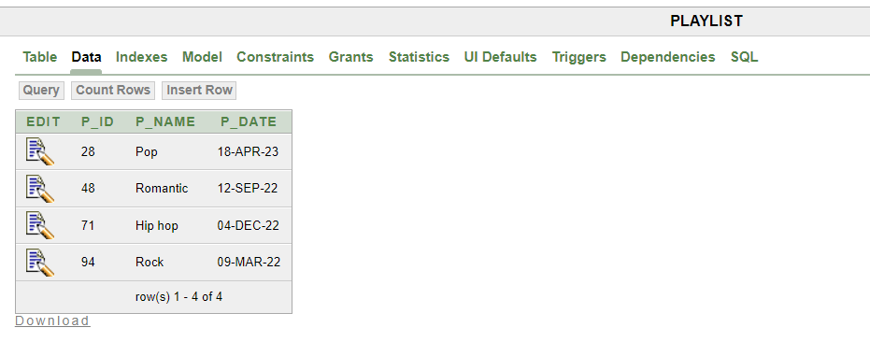

3) For tracks table :

INSERT into tracks values(8, 'Ei Obelay' , '23-Dec-19' , 3.08);

INSERT into tracks values(9, 'Hashimukh' , '21-Oct-04' , 4.25);

INSERT into tracks values(30, ' Nasek Nasek' , '23-Feb-22', 4.22);

INSERT into tracks values(124, 'Jawl Phoring 2.0' , ‘9-Mar-22’,3.08);

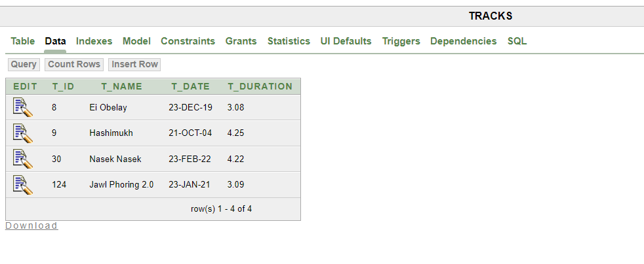

4) For genre table :

INSERT into genre values(1, 'Folk');

INSERT into genre values(2, 'Classical');

INSERT into genre values(3, 'Happy');

INSERT into genre values(4, 'Sad');

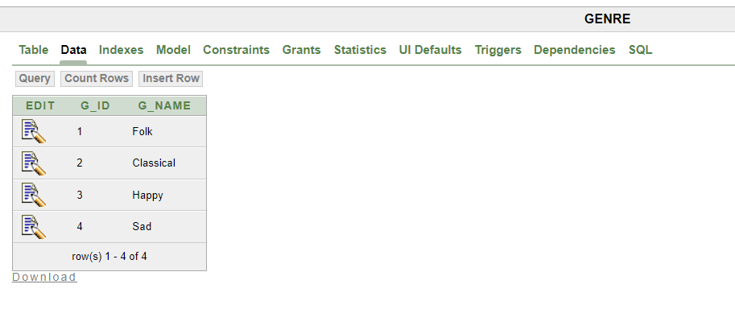

5) For artist table :

INSERT into artist values(14, 'Shironamhin', 'Bangladeshi',112);

INSERT into artist values(22, 'Anupom Roy', ‘Indian’113);

INSERT into artist values(35, 'Tahsan', ‘Bangladeshi’114);

INSERT into artist values(49, 'Shuvro', 'Bangladeshi'115);

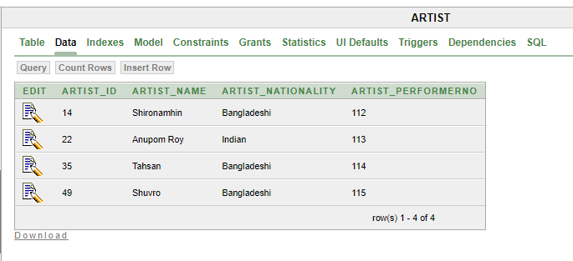

6) For album table :

INSERT into album values(64, 'Ei Obelay', '23-Dec-19');

INSERT into album values(92, 'Jahaji', '21-Oct-04');

INSERT into album values(175, 'Null', '23-Feb-22');

INSERT into album values(209, 'Null', '9-Mar-22');

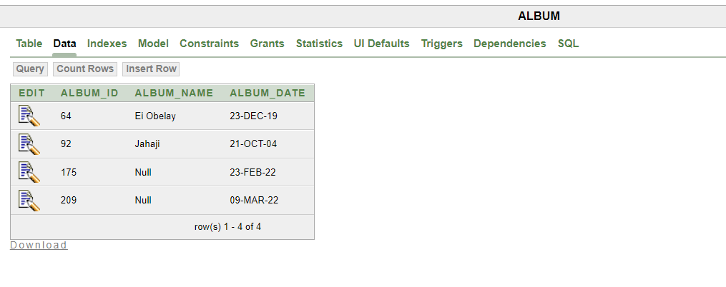

7) For makes table :

INSERT into makes values(101, 'Ujjoyeni', 'ujjoyeni@gmail.com', 28);

INSERT into makes values(102, 'Noman', 'noman@gmail.com',48);

INSERT into makes values(103, 'Saif', 'saif@gmail.com',71);

INSERT into makes values(104, 'Sourav', 'sourav@gmail.com',94);

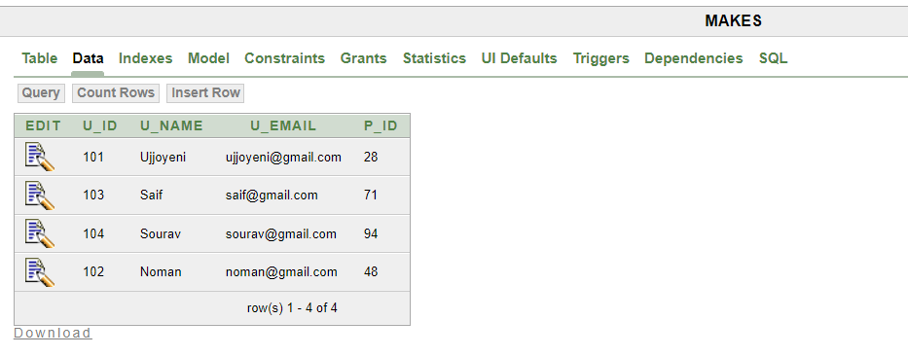

8) For listens table:

INSERT into listens values(101, 8);

INSERT into listens values(102, 9);

INSERT into listens values(103, 30);

INSERT into listens values(104, 124);

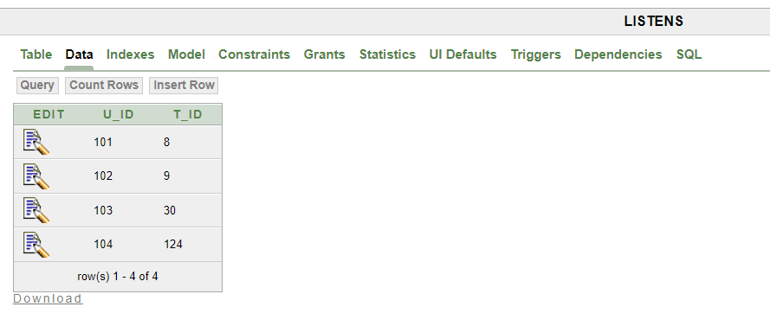

9) For contains table :

INSERT into contains values(28, 8);

INSERT into contains values(48, 9);

INSERT into contains values(71, 30);

INSERT into contains values(94, 124);

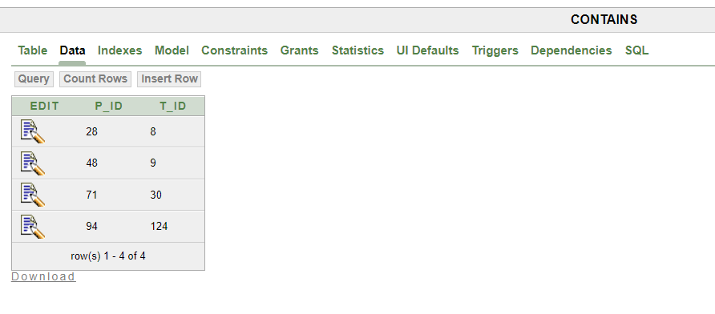

10) For composes table :

INSERT into composes values(14, 8);

INSERT into composes values(22, 9);

INSERT into composes values(35, 30);

INSERT into composes values(49, 124);

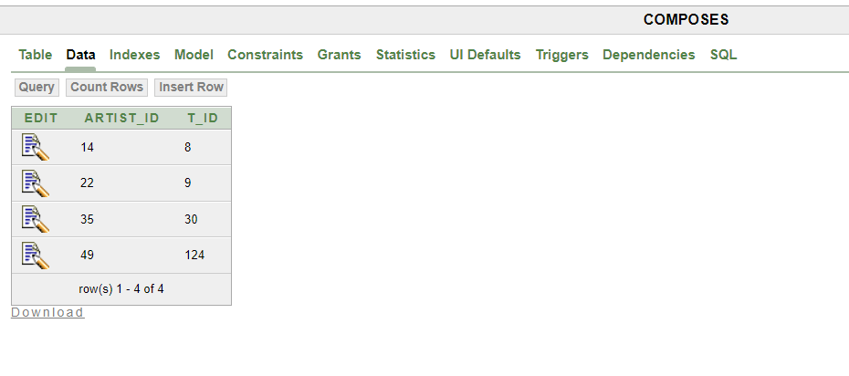

11) For creates table :

INSERT into creates values(14, 64);

INSERT into creates values(22, 92);

INSERT into creates values(35, 175);

INSERT into creates values(49, 209);

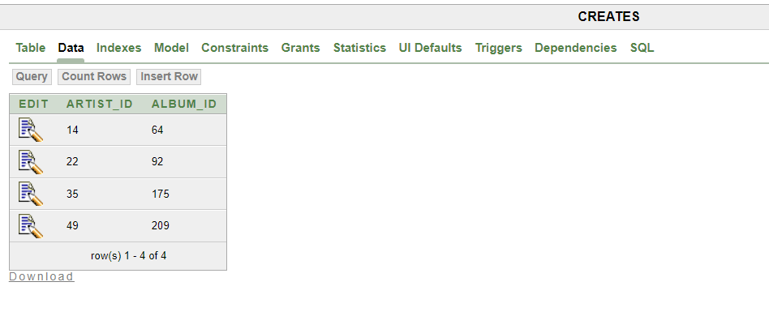

12) For has table :

INSERT into has values(64, 'Ei Obelay' , '23-Dec-19',8);

INSERT into has values(92, 'Jahaji', '21-Oct-04', 9);

INSERT into has values(175, 'Null', '23-Feb-22', 30);

INSERT into has values(209, 'Null', '9-Mar-22',124);

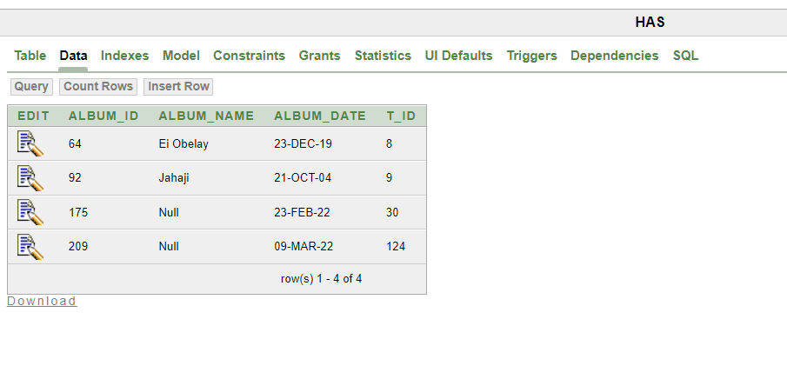

13) For belongs table :

INSERT into belongs values(8, 1);

INSERT into belongs values(9,2);

INSERT into belongs values(30, 3);

INSERT into belongs values(124, 4);

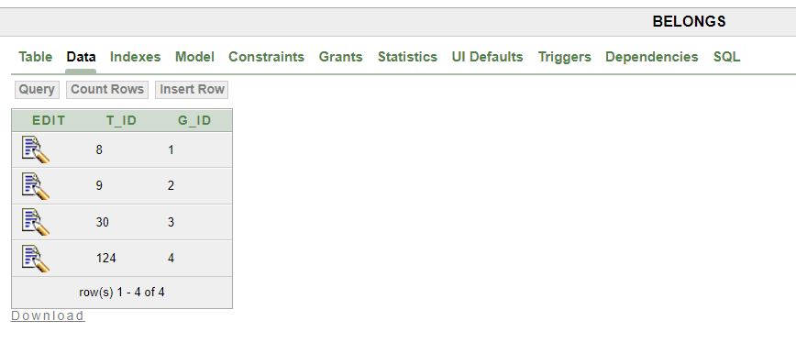

# 8. Query

***Single Row Subquery*** :

1)

Show the track names with duration less than that of the track, 'Hashimukh' :

SELECT t_name, t_duration

FROM tracks

WHERE t_duration <

(SELECT t_duration

FROM tracks

WHERE t_name = 'Hashimukh');

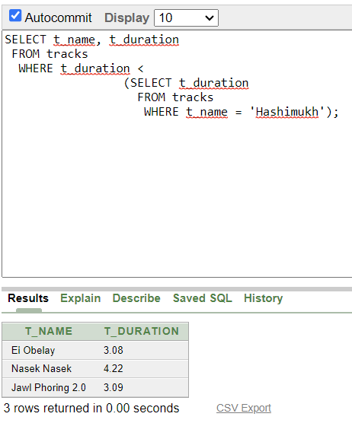

2) Show the album names and creation date that was created before t_id 30:

SELECT album_name, album_date

FROM has

WHERE album_date <

(SELECT t_date

FROM tracks

WHERE t_id = 30);

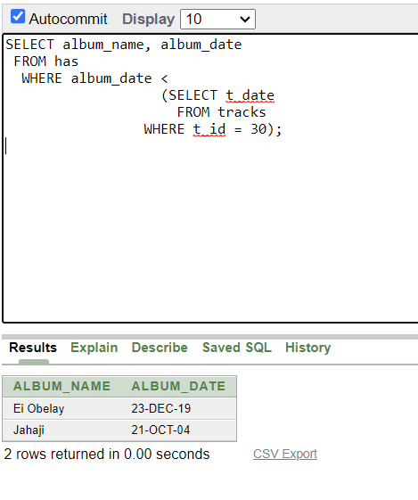

***Multiple Row Subquery*** :

3) SELECT artist_name

FROM artist

WHERE artist_id IN (

SELECT artist_id

FROM tracks

WHERE t_duration = (

SELECT MIN(t_duration)

FROM tracks

)

);

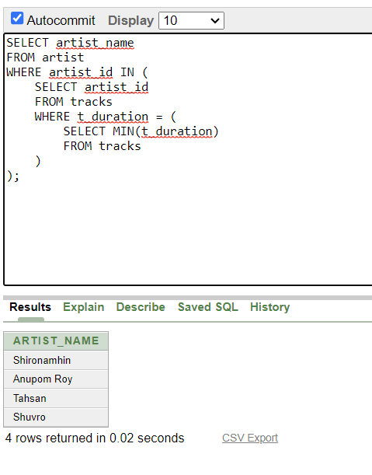

4) Show the user names who created a playlist after 9-Mar-22 :

SELECT u_name

FROM makes

WHERE p_id IN

(SELECT p_id

FROM playlist

WHERE p_date > '9-Mar-22');

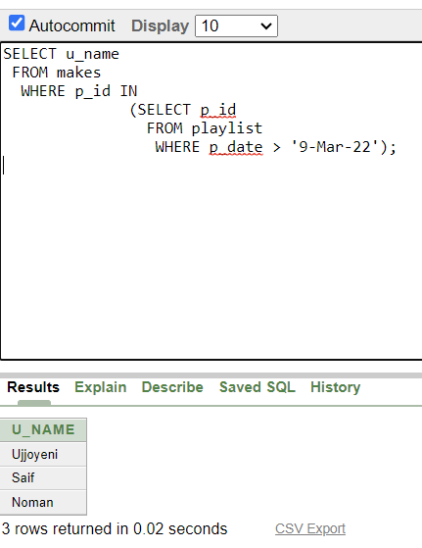

***Aggregate Function*** :

5) Show the minimum duration and the date of the last created track :

SELECT MIN(t_duration), MAX(t_date)

FROM tracks;

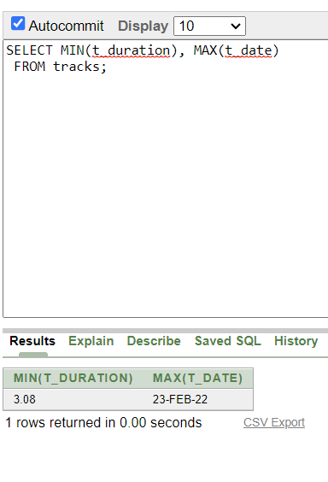

***Equijoin*** :

6) Show the track name, track duration, album name, album creation date

with proper joining condition :

SELECT t. t_name, t.t_duration, h. album_name, h. album_date

FROM tracks t, has h

WHERE t.t_id = h.t_id;

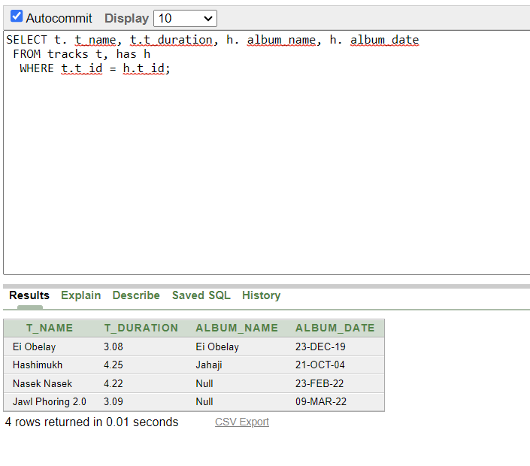

***Outer Join*** :

7) Show the track name, track creation date, genre name

with joining condition :

SELECT t.t_name, g.g_name, t.t_date

FROM tracks t, genre g, belongs b

WHERE t.t_id(+) = b.t_id AND g.g_id = b.g_id(+);

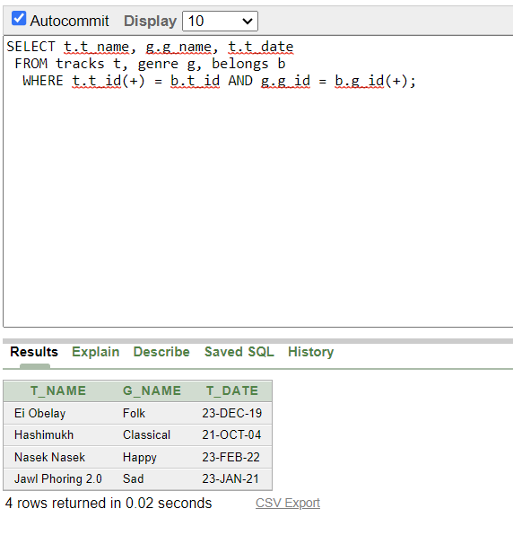

# 9. Conclusion

In conclusion, a music library management system that utilizes a database using SQL can greatly improve the efficiency and effectiveness of managing a music library. The music Library Management System is much more user-friendly, faster in operation and easy to manage than the manual one. Through the use of it, the librarian can manage the whole data of the library in a single database in different tables with a much more security than the traditional way.Overall, implementing a music library management system using a database with SQL can provide numerous benefits and streamline operations for library industy.